**Project Design Phase**

**Solution Architecture**

|  |  |
| --- | --- |
| Date | 20 March 2025 |
| Team ID | **SWTID1743689974** |
| Project Title | Bookstore |
| Maximum Marks | 2 Marks |

**Solution Architecture:**

**Key Objectives:**

* Secure user authentication and role-based access (Admin , Buyer)
* Scalable database with books, orders, users, and recommendations
* Personalized experience through genre filtering and wishlists

**Core Components:**

* **Frontend**: React.js – handles UI, dynamic rendering based on user role
* **Authentication**: Firebase – manages login/signup and user roles
* **Backend API**: Node.js + Express – processes business logic and routes
* **Database**: MongoDB Atlas – stores all data (users, books, orders, etc.)
* **Recommendations Engine**: Based on genres, user history
* **News Feed**: Dynamically fetched via external API or admin uploads
* **Wishlist & Cart**: Stored per user with real-time update support

**Solution Architecture Diagram:**

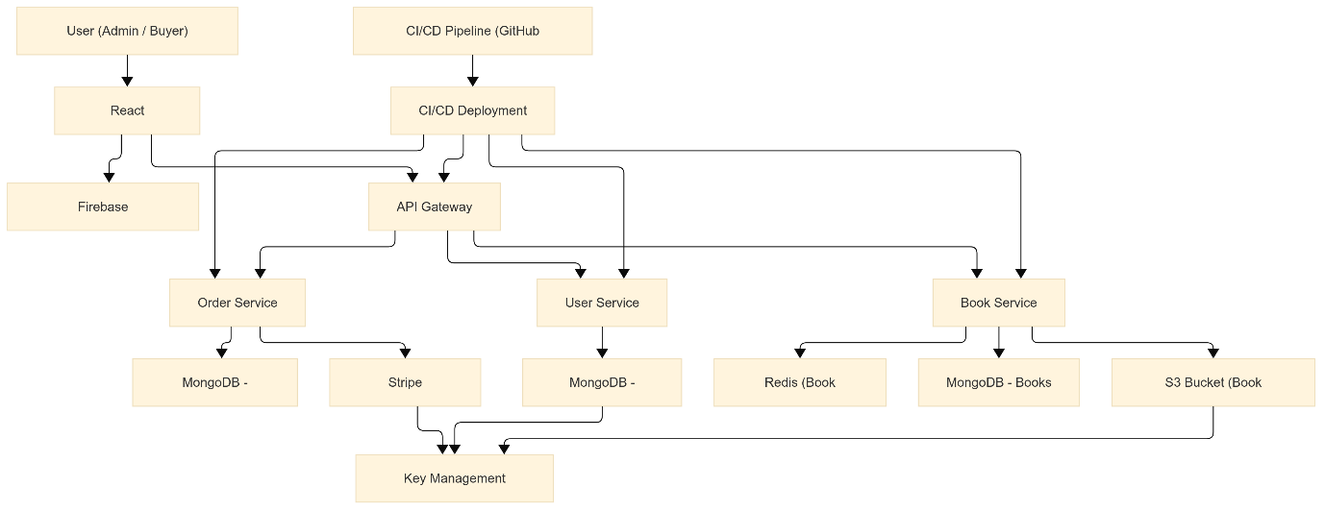

*Figure 1: Architecture and data flow of the Bookstore website*

**Reference:** [**https://aws.amazon.com/blogs/industries/voice-applications-in-clinical-research-powered-by-ai-on-aws-part-1-architecture-and-design-considerations/**](https://aws.amazon.com/blogs/industries/voice-applications-in-clinical-research-powered-by-ai-on-aws-part-1-architecture-and-design-considerations/)